**Mentor Searcher Set Up & Running Instructions**

Last updated: Sep 1, 2022

**Context:** The goal of this document is that a**nyone can follow the process** regardless of their set up or previous knowledge level - whether they use mac or pc, they’ve used python before or not. They should be able to **run the mentor searcher from the beginning to the end.**  For that reason, the instructions should be split into 4 parts:

1) setting up

2) running

3) validating the output

4) Upload to Monday

# Section 1 - Setting Up:

1. Install Python from the official Python website (NOTE: for Windows users, DO NOT install Python from the Microsoft Store). Follow these steps for both Mac or Windows:
   1. Go to this website: <https://www.python.org/downloads/>
   2. Scroll down and look for the ‘specific release’ section: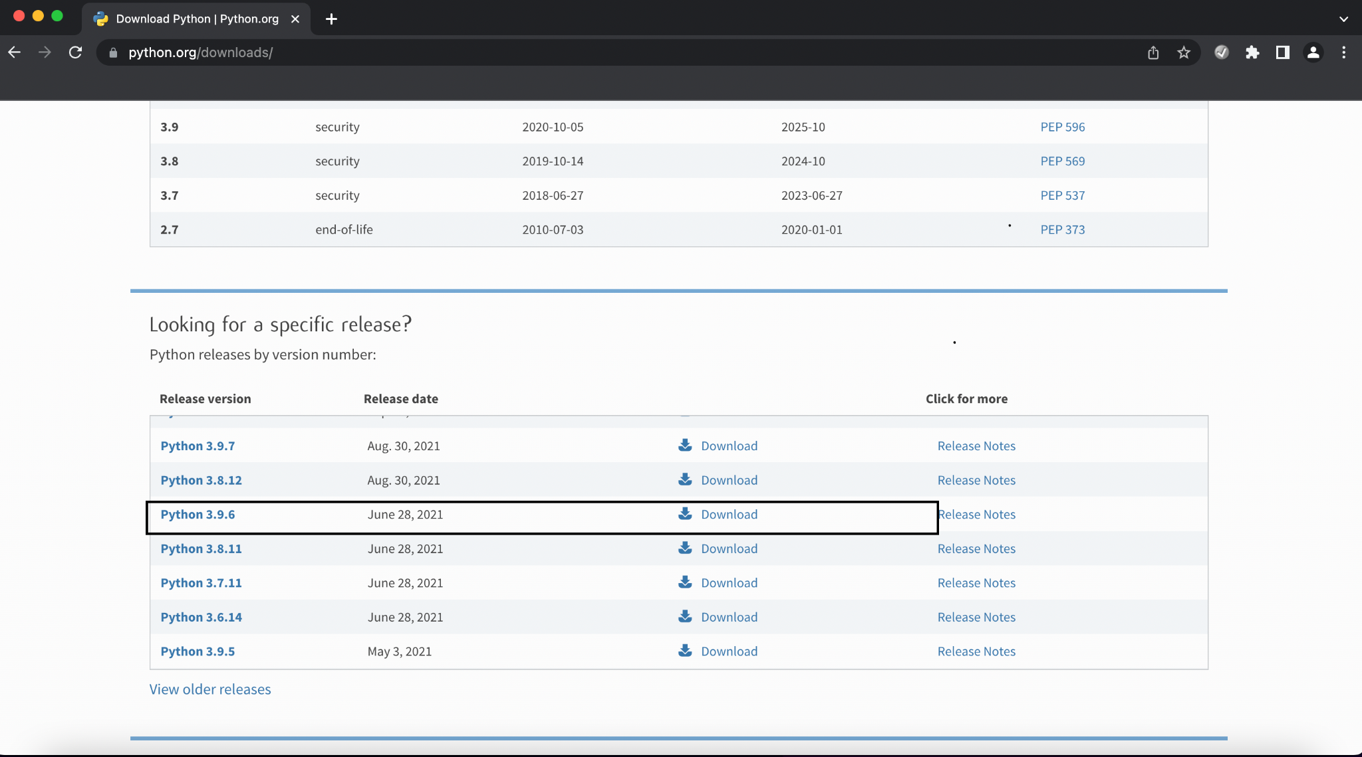
   3. Install Python 3.9.6
2. Once installed, confirm if Python is installed properly:
   1. **For Windows:** 
      1. Click Start (the ‘Windows’ shaped button on the taskbar)
      2. Type **PowerShell** in the search bar
      3. Click on Windows PowerShell to open the PowerShell window
      4. Right click on the PowerShell icon and select ‘pin to taskbar’
      5. Click on the PowerShell window and type:

py

* + 1. You should see this in your PowerShell window: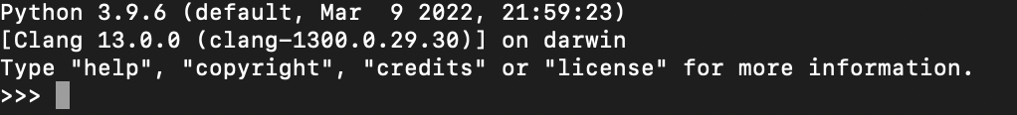
    2. If you see the above picture, that means Python has been successfully installed!
       1. NOTE: If ‘py’ command doesn’t work, try typing:

python

* + 1. Now type this:

exit()

* + 1. And press enter. This will exit the Python environment back to the PowerShell environment.
  1. **For Mac:**
     1. Open search bar by using this shortcut:

Cmd + space keys together

* + 1. Type this and click on the application:

terminal

* + 1. When Terminal is open, you should see the app on your dock (yellow box). Right click the terminal app and select ‘options’.Then select ‘keep in dock’: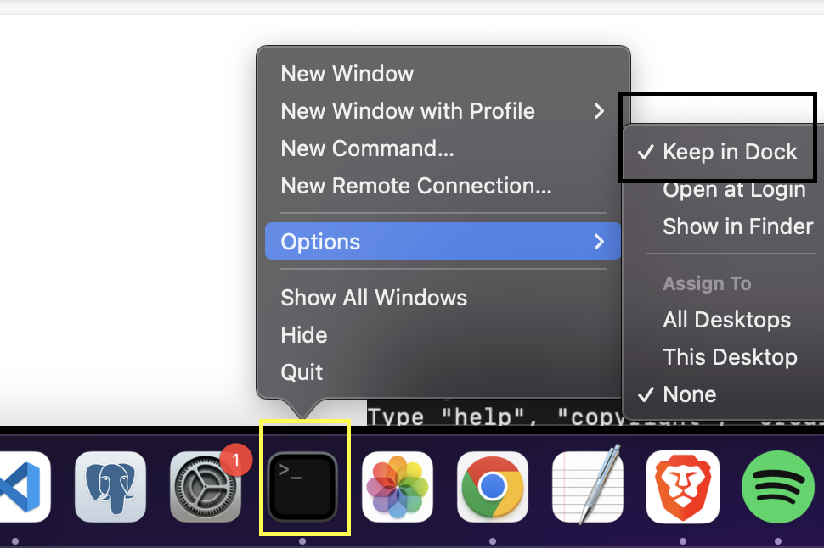
    2. Now open the Terminal. When you see the terminal window, type ‘python’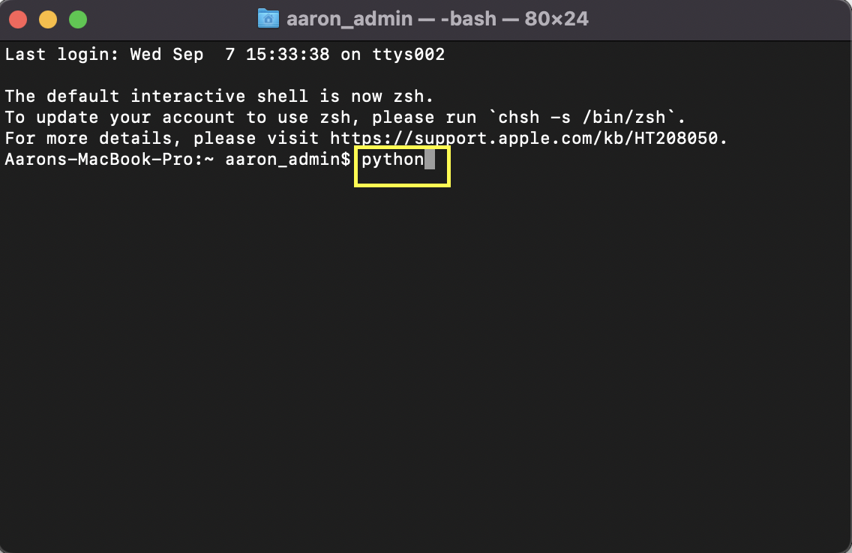
    3. You should see this: 
    4. Now type:

exit()

* + 1. And press enter. This will exit the python environment back to the terminal environment

1. Once Python is installed, you need to install Poetry
   * **For Windows:**
     + Open PowerShell (see instructions above)
     + Paste this command in the terminal and then press enter:

(Invoke-WebRequest -Uri https://install.python-poetry.org -UseBasicParsing).Content | py -

If this doesn’t work, try:

(Invoke-WebRequest -Uri https://install.python-poetry.org -UseBasicParsing).Content | python -

* + - Once the download has finished, take a screenshot of the PowerShell output!! For example:
    - 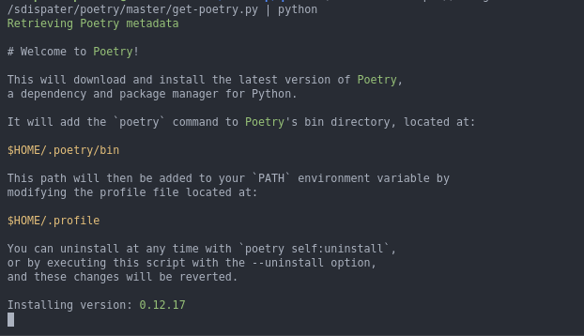
      * **This is very important. The information in the screenshot helps us complete the final step in the installation. The final steps are:**
      * In the PowerShell window, now type:

notepad $profile.CurrentUserAllHosts

* + - * The ‘notepad’ app will open up. Notepad is a text editor, just like Microsoft ‘Word’.

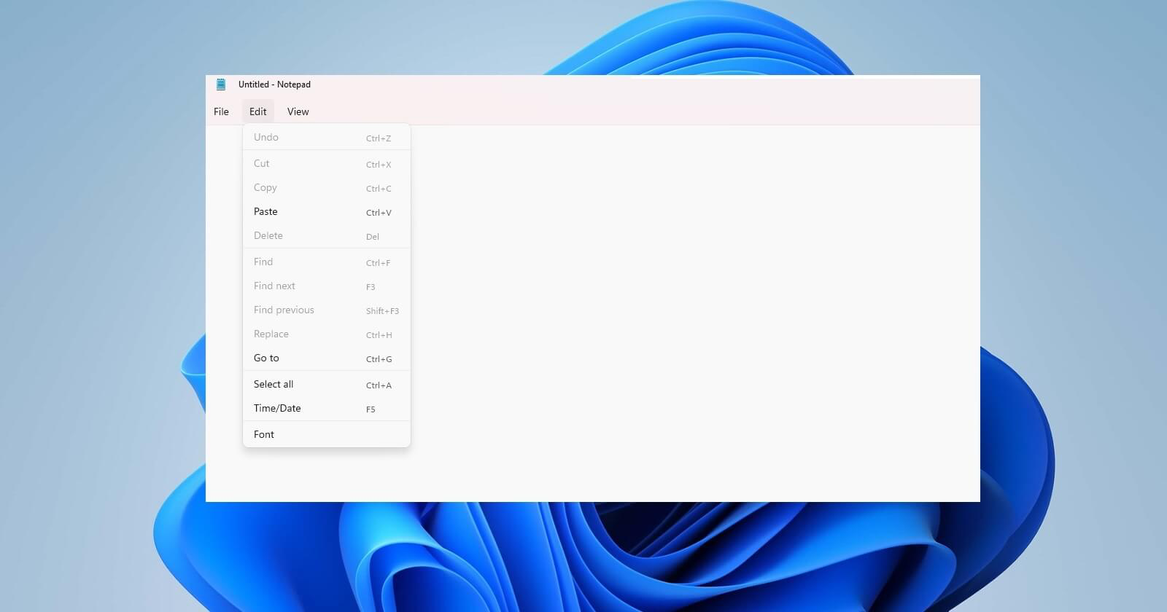

* + - * In the notepad window, paste:

$env:Path += "(the address in the screenshot you took)"

**For example, in the below screenshot, the address can be found here 1. in the screenshot, first look for the line containing the word ‘directory’;**

**2. the text with ‘/’s beneath it is the address:**



**For windows it is likely to be this address:**

C:Users\(Your username)\AppData\Roaming\Python\Scripts

**BUT IT VARIES WITH EVERY COMPUTER - REFER TO THE SCREENSHOT YOU TOOK FOR THE RIGHT ADDRESS**

**So using the above example address in the screenshot, you would type in Notepad:**

$env:Path += "$HOME/.poetry/bin"

Save the file and close notepad.

* + - * **Close** PowerShell and **restart** it.
      * Now test if poetry has been installed correctly - go to PowerShell and type:

poetry --versions

* + - * If you see something like ‘Poetry (version 1.2.0)’, your install is ready to use!
      * For further reference, please consult:
        + https://python-poetry.org/docs/
  + **For Mac:**
    - Open the terminal (see instructions on how to open above)
    - Paste this command in the terminal and then press enter:

curl -sSL https://install.python-poetry.org | python3 -

* Take a screenshot of the terminal output!!
* 
  + **This is very important. The information in the screenshot helps us complete the final step in the installation. The final steps are:**
  + In the terminal window, now type:

open -e ~/.bash_profile

* + The ‘TextEdit’ app will open up. ‘TextEdit’ is a text editor, just like Microsoft ‘Word’.

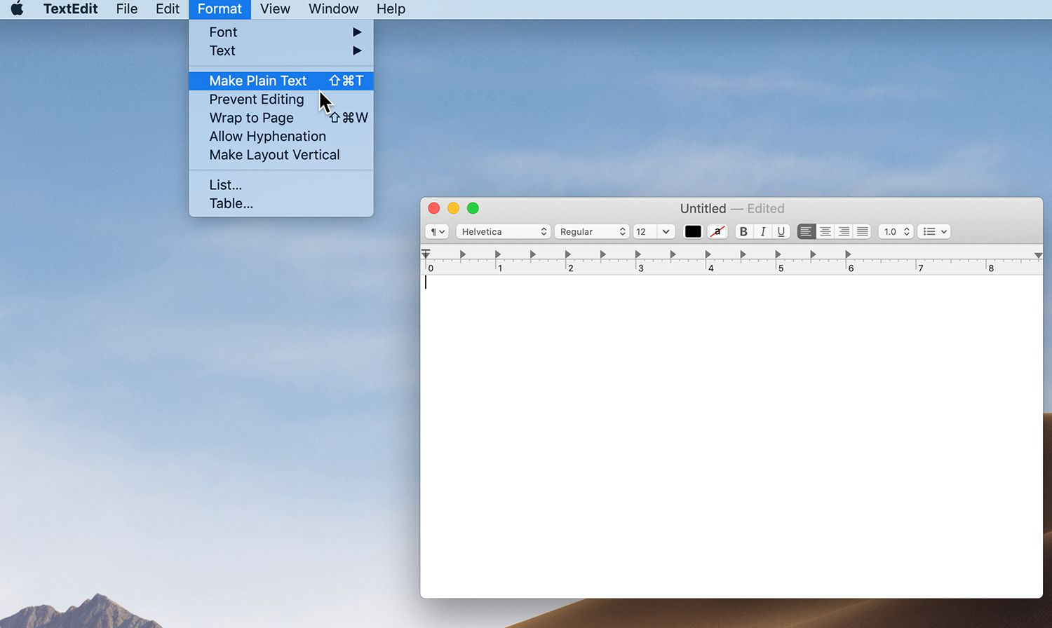

* + In the TextEdit window, paste at the beginning of the file:

export PATH="(the address in the screenshot you took):$PATH"

**For example, in the below screenshot, the address can be found here: 1. in the screenshot, first look for the line containing the word ‘directory’;**

**2. the text with ‘/’s beneath it is the address:**



**For Mac it is likely to be this address:**

/Users/(Your Username)/.poetry/bin

**BUT IT VARIES WITH EVERY COMPUTER - REFER TO THE SCREENSHOT YOU TOOK FOR THE RIGHT ADDRESS**

**So for example, using the above address you would type in TextEdit:**

export PATH="/Users/(Your Username)/.poetry/bin:$PATH"

* + Save the file and close TextEdit.
  + Close Terminal and restart it.
    - * Now test if poetry has been installed correctly - go to terminal and type:

poetry --versions

* + - * If you see something like ‘Poetry (version 1.2.0)’, your install is ready to use!
      * For further reference, please consult:
        + https://python-poetry.org/docs/

1. Once you have ‘Poetry’ and ‘Python’ installed, ask Aaron to send you the code. It will be in a zip file.
2. Once downloaded, unzip the file contents into another folder so you can see what’s inside.

So from:

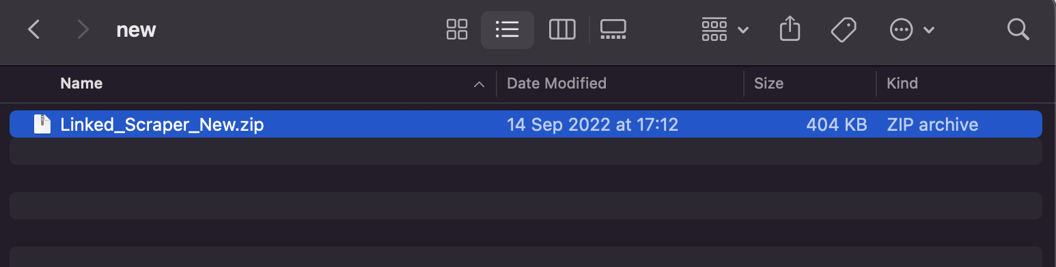

To:

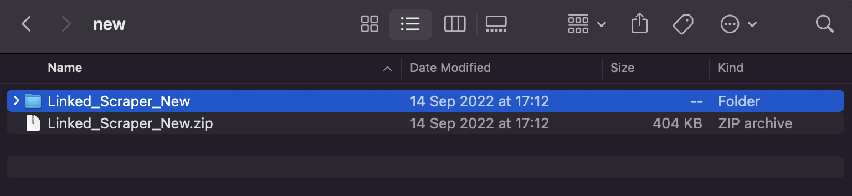

Once you’ve completed step 5 and you can see the file contents, you’ve successfully downloaded all the necessary tools to run the mentor searcher.

File contents:

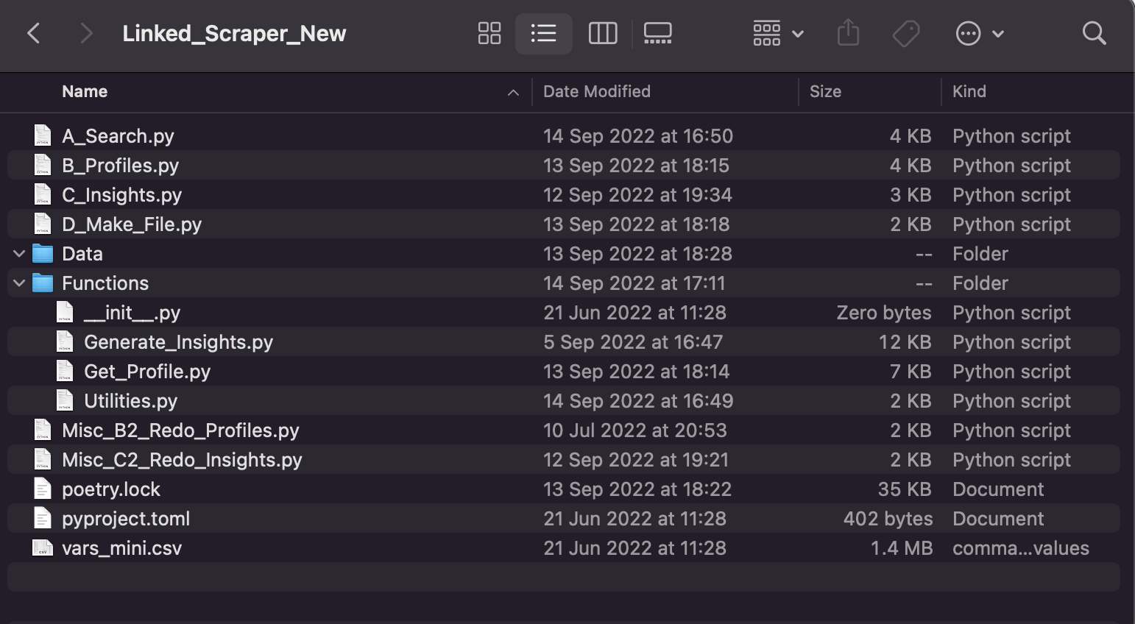

# Section 2 - Running the Program

1. Open the above folder, but **in the terminal**:
   1. For Windows, follow these instructions:
      1. Open the ‘Folders’ app
      2. Go to the folder which contains ‘LinkedIn_Scraper_New’
      3. Right-click on the folder. You should see this:
      4. 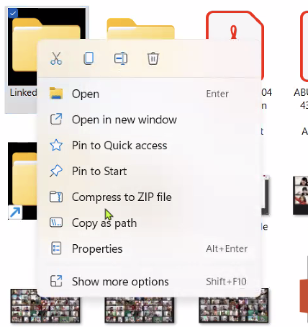
      5. Click ‘Copy as path’
      6. Open PowerShell (you should have PowerShell pinned to your taskbar already; if not, see above on how to do so)
      7. Paste in PowerShell:

cd (paste what you copied in step v)

So for example:

Cd “C:Users\(Your username)\Desktop\LinkedIn_Scraper_New”

(don’t forget the open and close quotations, in red highlight)

* + 1. Press enter
  1. For Mac:
     1. Go to the folder you want to open.
     2. Select the folder, right-click on it, and then select ‘New Terminal at folder’.
     3. 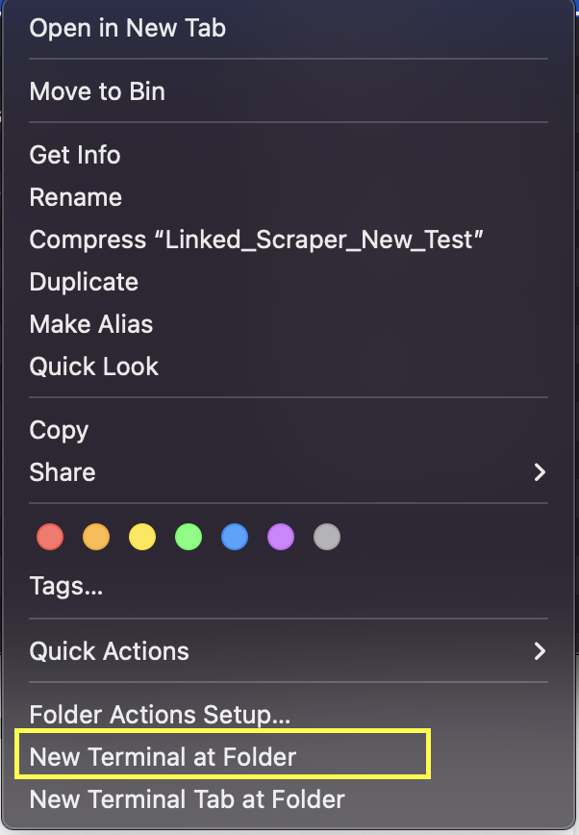
     4. A new Terminal window opens directly to the selected folder.

1. If this is your **first time** running the linkedin scraper, type in terminal:

poetry install

1. If you have run the program before, type instead:

poetry run python A_Search.py

1. Follow the interactive prompts.
   1. The complete interaction:
2. 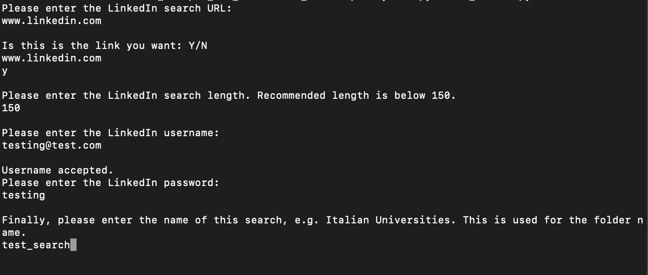
   1. Ask Giuseppe or Jenna for their respective login details.
   2. The link can usually be found in <https://docs.google.com/spreadsheets/d/1ADgEjq_OvPG53S0C5vVP0sDOEzAsUvBEuzE_JHr_eYY/edit#gid=1722944599>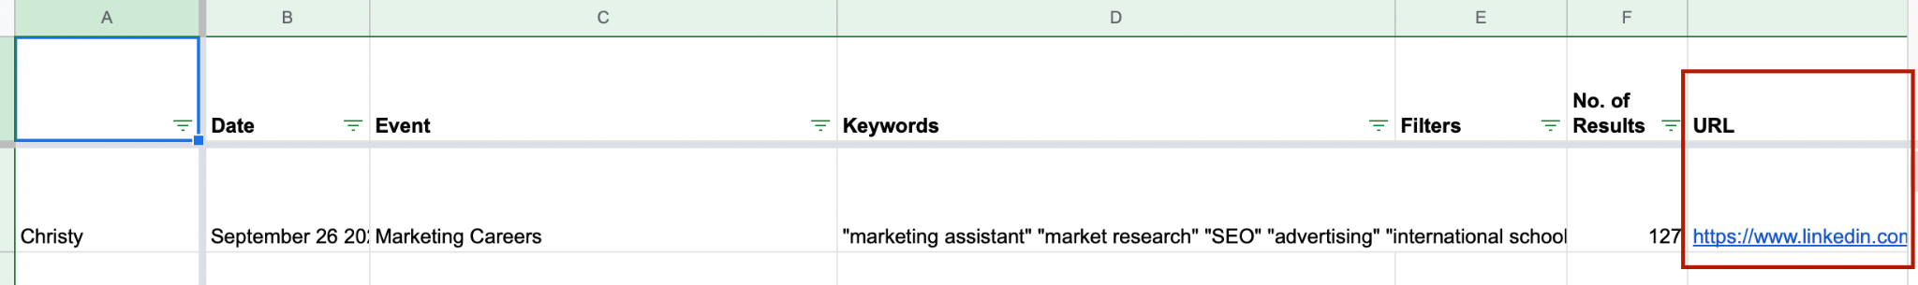
      1. Otherwise consult the ‘mentor network searcher’ channel on Slack: <https://wearemillie.slack.com/archives/C0354TZ2ECE>
   3. For ‘search length’, also consult the google sheet:

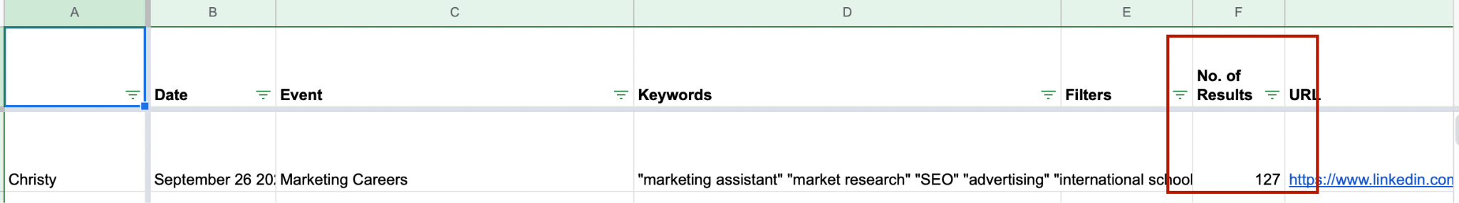

1. Once the required details have been filled in, the program would automatically run.
2. If you encounter LinkedIn’s security code verification, organise a session with Giuseppe (primary) and Jenna (secondary) to get access to their account.
3. Once step A has completed, you should see this:
4. 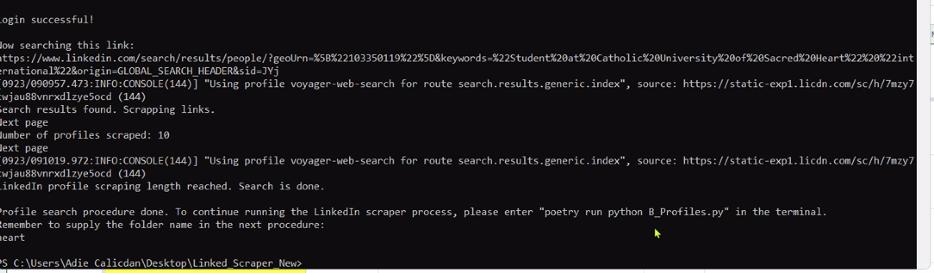
5. **NOTE the last 4 lines of the above picture contains instructions on how to proceed (consult the “please run “**poetry run python B_Profiles.py” **in the terminal” line**; **the ‘folder name’ reminder is also important!! You’ll know why in the next bullet point**)
6. Following the instructions in the terminal, type:

poetry run python B_Profiles.py

You should see this:

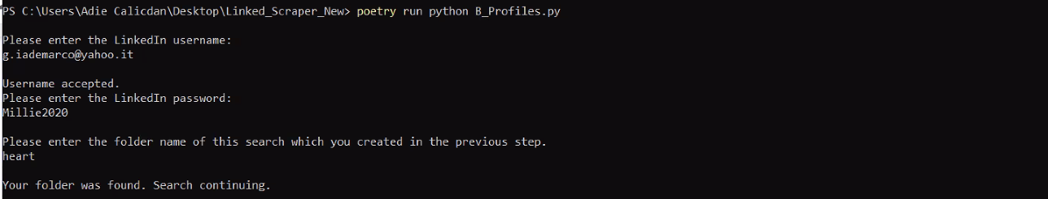

1. DON’T FORGET TO SUPPLY THE FOLDER NAME YOU SET PREVIOUSLY IN STEP A (the terminal output contains a reminder; if you don’t know where it is, consult bullet point 10 above)
2. The search will then being.
   1. If more than 50% of the search results have ‘error’ in them, reach out to Aaron and he’ll take over running the program for this search. Otherwise just ignore the errors; the program will still run, it’ll just ignore the errors.
3. Once step B has finished running, you should see these instructions:
4. 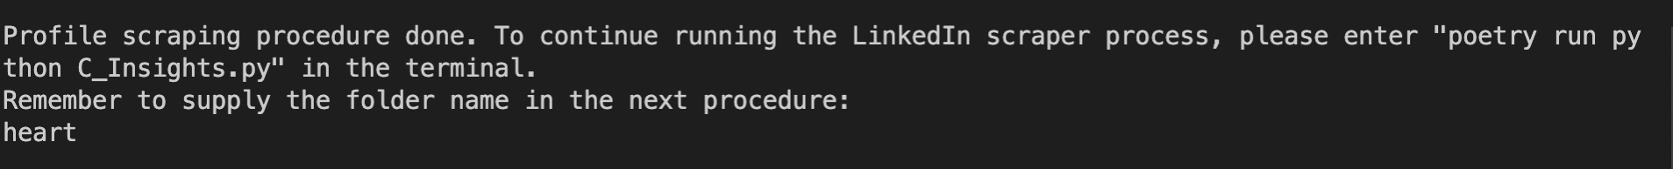
5. Again following the instructions, proceed to part C:

poetry run python C_Profiles.py

1. The output should be so:
2. 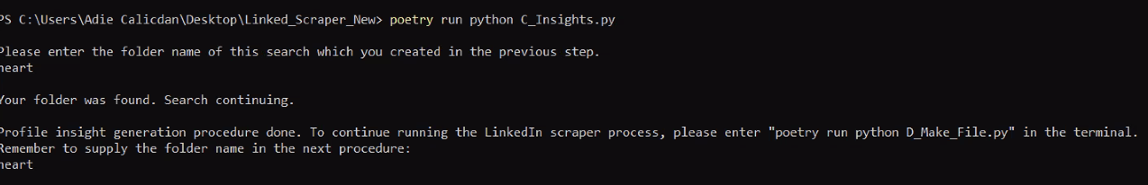
3. Again following the instructions in the terminal, enter

poetry run python D_Make_File.py

1. 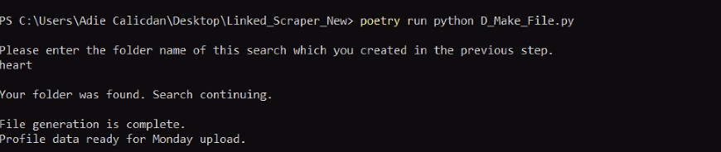
2. You should now have a new file in the ‘Data’ folder within the code:
3. 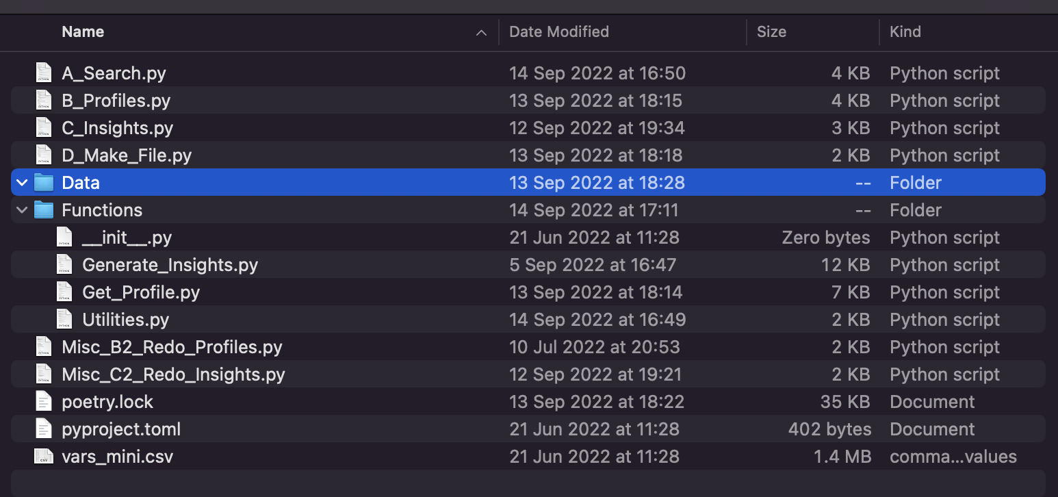
4. Using the above example, whose folder name was ‘heart’, you should see:
5. 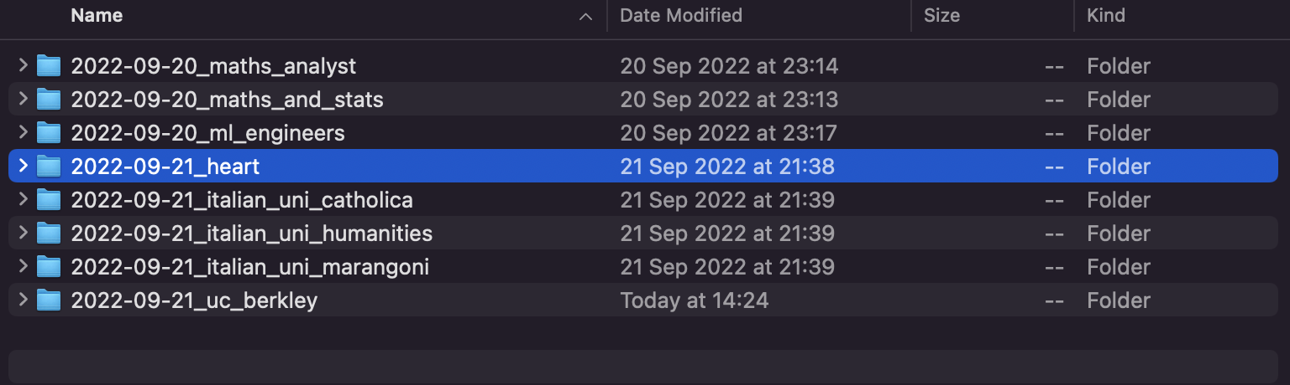
6. If you click on that folder, you should see this:
7. 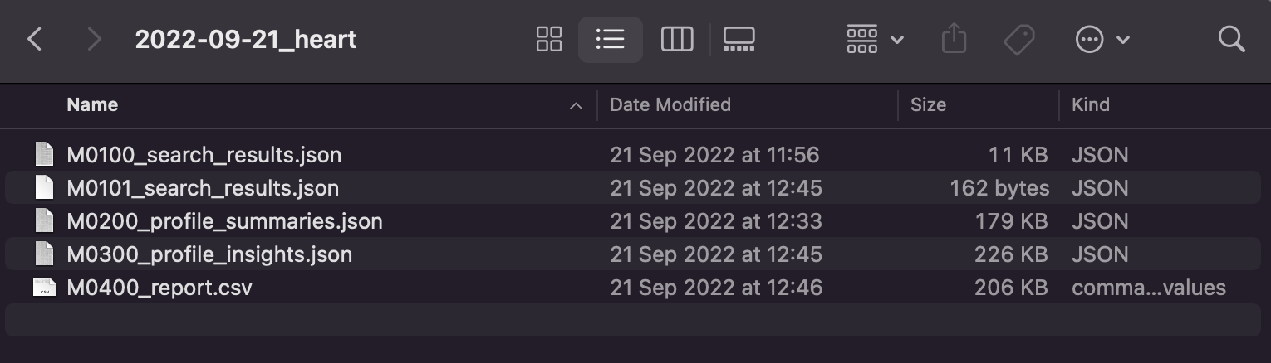
8. ‘M0400_report.csv’ is the file we want!

# Section 3 - Confirm output is correct

A_Search.py

Provide the program with this linkedin profile:

https://www.linkedin.com/in/ikjot-kahlon-7b552617a?miniProfileUrn=urn%3Ali%3Afs_miniProfile%3AACoAACpvqvkB_v3BFwLjKRVZ0RPFv4pyxG1zco8

B_Profiles.py should return:

[{"summary":["Ikjot Kahlon","Undergraduate Student at The University of British Columbia","RE/MAX","The University of British Columbia","British Columbia, Canada"],"potential_mentor":false,"languages_spoken":["English","French","Punjabi"],"schools":[["The University of British Columbia","UBC Sauder School of Business"],["Bachelor of Science - BS, Biology, General","Real Estate Trading Services"],["Sep 2018 - Apr 2023","Dec 2020 - Dec 2021"],["Currently an undergraduate student.","Currently studying to get licensed as a Real Estate Agent."]],"work_exp":[["Real Estate Agent","Sterilization Technician"],["RE/MAX · Self-employed","Penticton Dental Arts"],["Jun 2022 - Present · 4 mos","Sep 2020 - Present · 2 yrs 1 mo"],["Penticton, British Columbia, Canada","No location"],["No description","Assisted in the sterilization of instruments used by the dental staff. Helped seat patients, directed questions to the dentist, and answered phone calls when required."]],"LinkedIn url":"https://www.linkedin.com/in/ikjot-kahlon-7b552617a?miniProfileUrn=urn%3Ali%3Afs_miniProfile%3AACoAACpvqvkB_v3BFwLjKRVZ0RPFv4pyxG1zco8"}]

Use <https://app.copyleaks.com/text-compare> to compare the above results with what you have received.

Once you have compared your results with the results above, run:

C_Insights.py. This output should be:

[{"Name": "Ikjot Kahlon, Undergraduate Student at The University of British Columbia", "Languages": ["English", "French", "Punjabi"], "Primary institution": "The University of British Columbia", "Years of experience": 0, "International school?": false, "School country": "", "School primary curriculum": "", "More Details": "", "Interested in mentoring?": false, "Location": "British Columbia, Canada", "LinkedIn url": "https://www.linkedin.com/in/ikjot-kahlon-7b552617a?miniProfileUrn=urn%3Ali%3Afs_miniProfile%3AACoAACpvqvkB_v3BFwLjKRVZ0RPFv4pyxG1zco8", "Full info": {"summary": ["Ikjot Kahlon", "Undergraduate Student at The University of British Columbia", "RE/MAX", "The University of British Columbia", "British Columbia, Canada"], "potential_mentor": false, "languages_spoken": ["English", "French", "Punjabi"], "schools": [["The University of British Columbia", "UBC Sauder School of Business"], ["Bachelor of Science - BS, Biology, General", "Real Estate Trading Services"], ["Sep 2018 - Apr 2023", "Dec 2020 - Dec 2021"], ["Currently an undergraduate student.", "Currently studying to get licensed as a Real Estate Agent."]], "work_exp": [["Real Estate Agent", "Sterilization Technician"], ["RE/MAX · Self-employed", "Penticton Dental Arts"], ["Jun 2022 - Present · 4 mos", "Sep 2020 - Present · 2 yrs 1 mo"], ["Penticton, British Columbia, Canada", "No location"], ["No description", "Assisted in the sterilization of instruments used by the dental staff. Helped seat patients, directed questions to the dentist, and answered phone calls when required."]], "LinkedIn url": "https://www.linkedin.com/in/ikjot-kahlon-7b552617a?miniProfileUrn=urn%3Ali%3Afs_miniProfile%3AACoAACpvqvkB_v3BFwLjKRVZ0RPFv4pyxG1zco8"}}]

If you then run D_Make_File.py, you should get these results in tabular form:

​​

| Name | Languages | Primary institution | Years of experience | International school? | School country | School primary curriculum | More Details | Interested in mentoring? | Location |
| --- | --- | --- | --- | --- | --- | --- | --- | --- | --- |
| Ikjot Kahlon, Undergraduate Student at The University of British Columbia | ['English', 'French', 'Punjabi'] | The University of British Columbia | 0 | False |  |  |  | False | British Columbia, Canada |

| LinkedIn url | Full info |
| --- | --- |
| https://www.linkedin.com/in/ikjot-kahlon-7b552617a?miniProfileUrn=urn%3Ali%3Afs_miniProfile%3AACoAACpvqvkB_v3BFwLjKRVZ0RPFv4pyxG1zco8 | {'summary': ['Ikjot Kahlon', 'Undergraduate Student at The University of British Columbia', 'RE/MAX', 'The University of British Columbia', 'British Columbia, Canada'], 'potential_mentor': False, 'languages_spoken': ['English', 'French', 'Punjabi'], 'schools': [['The University of British Columbia', 'UBC Sauder School of Business'], ['Bachelor of Science - BS, Biology, General', 'Real Estate Trading Services'], ['Sep 2018 - Apr 2023', 'Dec 2020 - Dec 2021'], ['Currently an undergraduate student.', 'Currently studying to get licensed as a Real Estate Agent.']], 'work_exp': [['Real Estate Agent', 'Sterilization Technician'], ['RE/MAX · Self-employed', 'Penticton Dental Arts'], ['Jun 2022 - Present · 4 mos', 'Sep 2020 - Present · 2 yrs 1 mo'], ['Penticton, British Columbia, Canada', 'No location'], ['No description', 'Assisted in the sterilization of instruments used by the dental staff. Helped seat patients, directed questions to the dentist, and answered phone calls when required.']], 'LinkedIn url': 'https://www.linkedin.com/in/ikjot-kahlon-7b552617a?miniProfileUrn=urn%3Ali%3Afs_miniProfile%3AACoAACpvqvkB_v3BFwLjKRVZ0RPFv4pyxG1zco8'} |

You now know how to scrape LinkedIn profiles! Continue to section 4.

# Section 4 - Upload data to Monday

1. Once you have generated the ‘M0400_report.csv’ file (see: above process), that data needs to be uploaded to **Monday.com**
2. First consult the Google sheet <https://docs.google.com/spreadsheets/d/1ADgEjq_OvPG53S0C5vVP0sDOEzAsUvBEuzE_JHr_eYY/edit#gid=1722944599> for
   1. The name of the table to upload your data to on Monday.com
   2. The person you should assign the table to
   3. 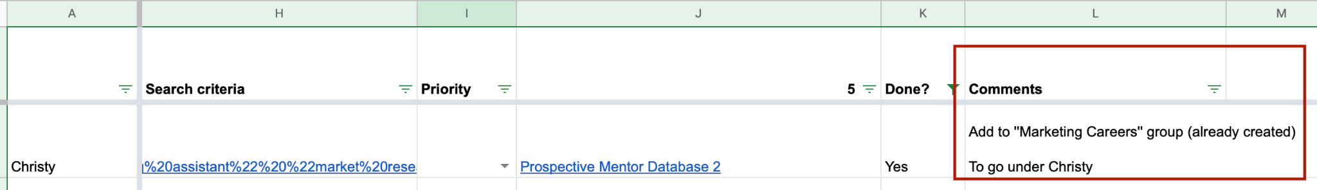
3. Click on column J which would lead you to Monday.com

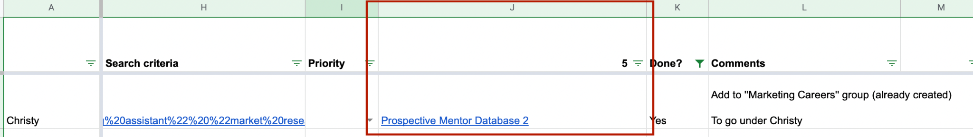

1. Once on Monday.com, go to ‘Prospective Mentor Database 3’ (look at the menu bar on the left of the page:)

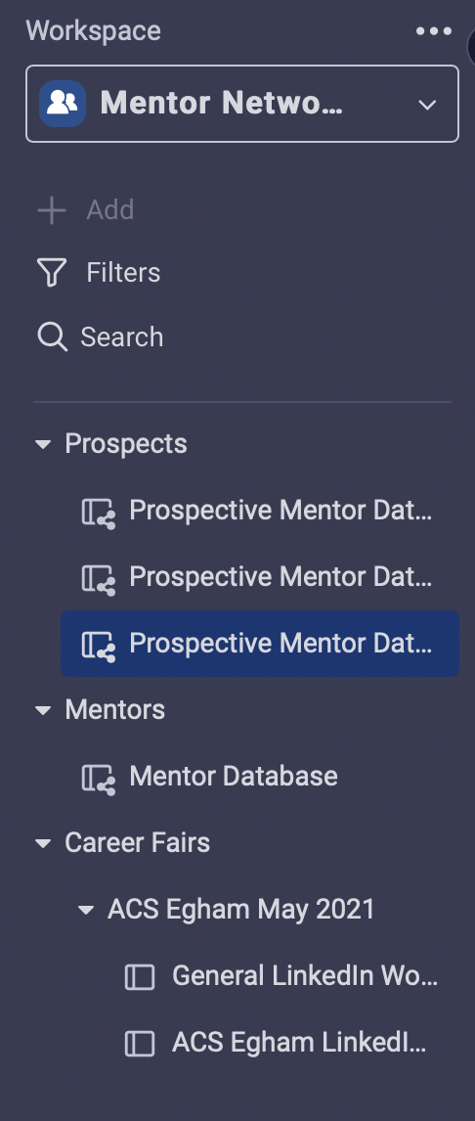

1. IF YOU CANNOT FIND THE GROUP NAME (in the above screenshot, for Christy’s group, the group name is ‘Marketing Careers’), scroll to the bottom of the page and select ‘Add new group’

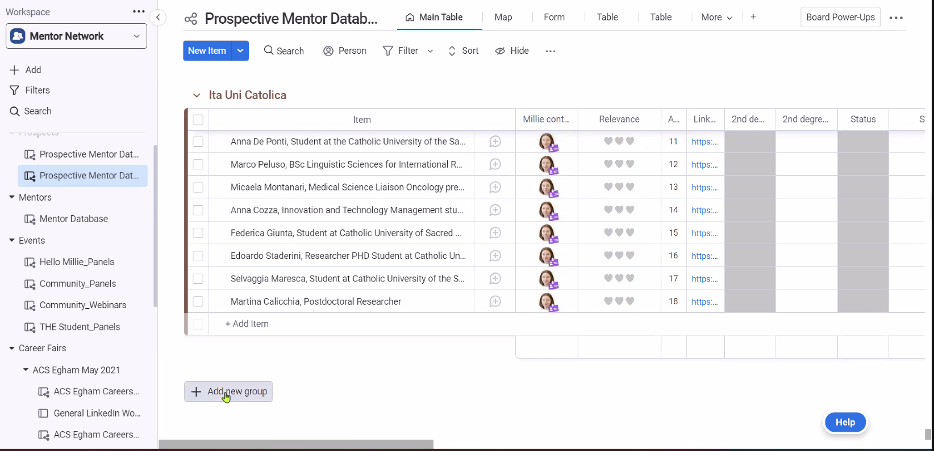

Usually the person on the mentor network search slack channel will notify you if a new group needs to be added:

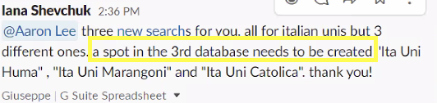

1. Once you have confirmed the group exists, it’s time to import the data in ‘M0400_report.csv’. In the bottom left corner, where your Monday.com profile picture is, click on it and select ‘**Import data**’:

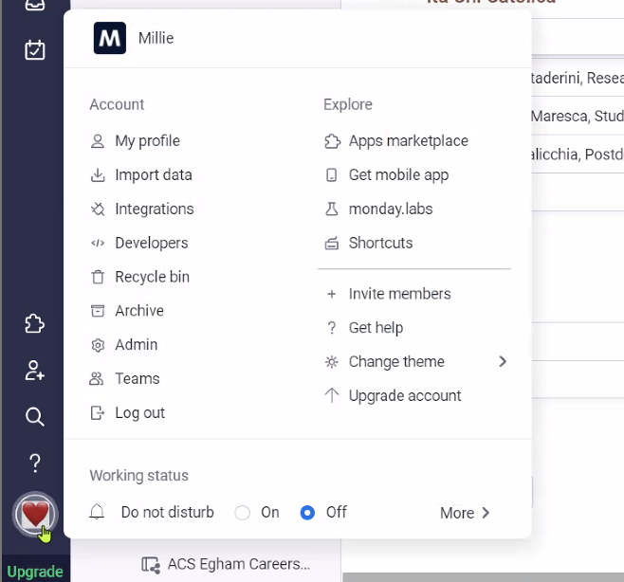

1. You will see this window:

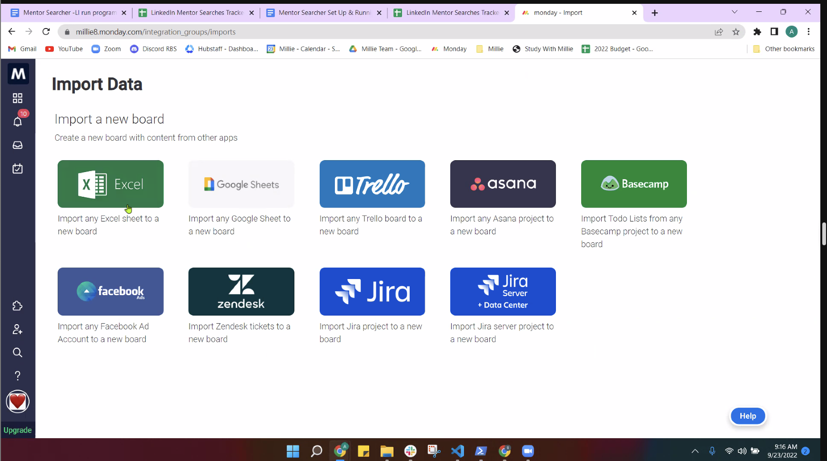

Select the ‘Excel’ option

1. Once you have selected the upload ‘Excel’ option, they will ask you if ‘What is your first row’ and if ‘What is your first column’. There is nothing to change here. Click the bottom right blue button (highlighted in a yellow bar in the below screenshots) to continue.

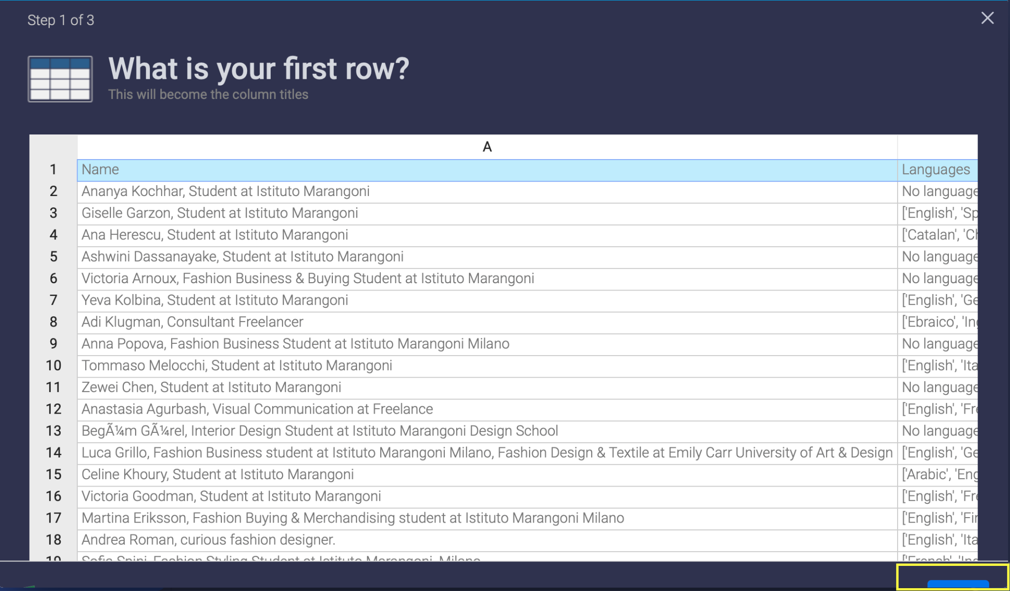

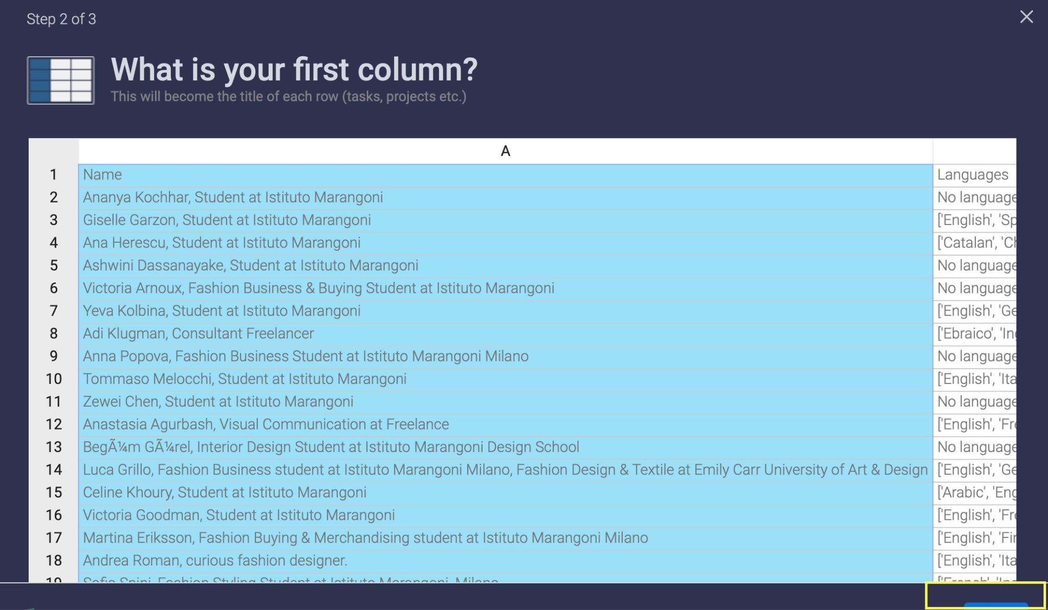

1. Finally this should come up:

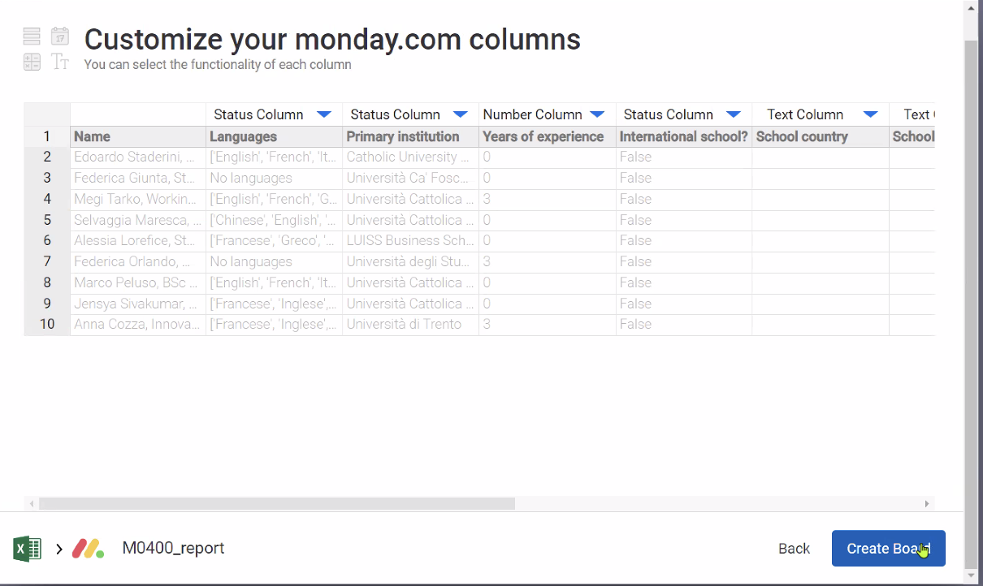

M**AKE SURE YOU CHANGE ALL THE COLUMN STATUSES TO TEXT:**

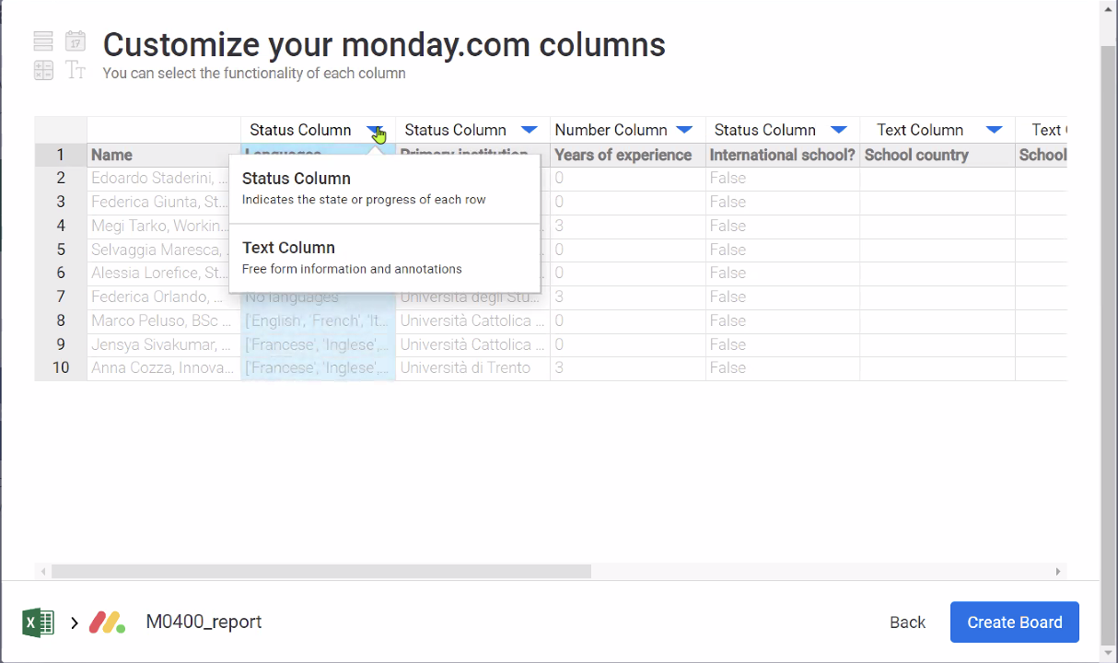

1. Once you have changed all column statuses to ‘text’, you can create board. Click on the bottom right blue button:

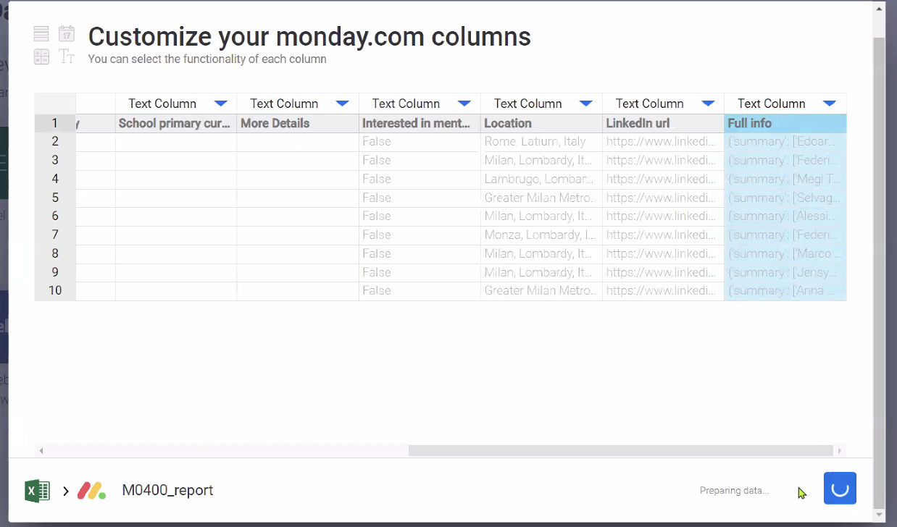

1. Once the upload is complete, you should see this:

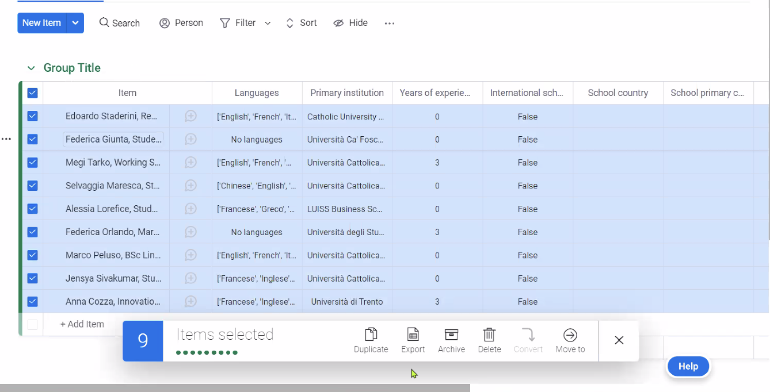

To select all rows, check the box on the top left corner

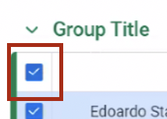

1. Once you have selected all the data, you can move them to the appropriate Monday.com group.

**Click ‘Move to’**

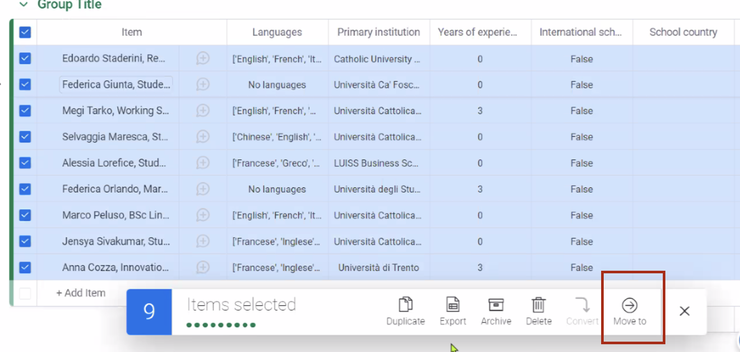

**Click on ‘Move to board’**

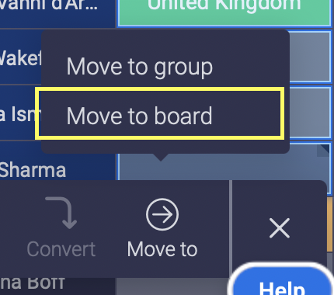

**Select ‘Prospective Mentor Database 3’**

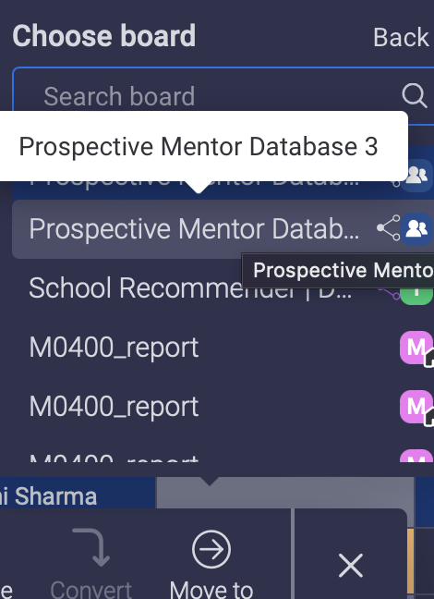

Type the appropriate group name in the seach bar. In Christy’s example, it would be ‘Marketing Careers’

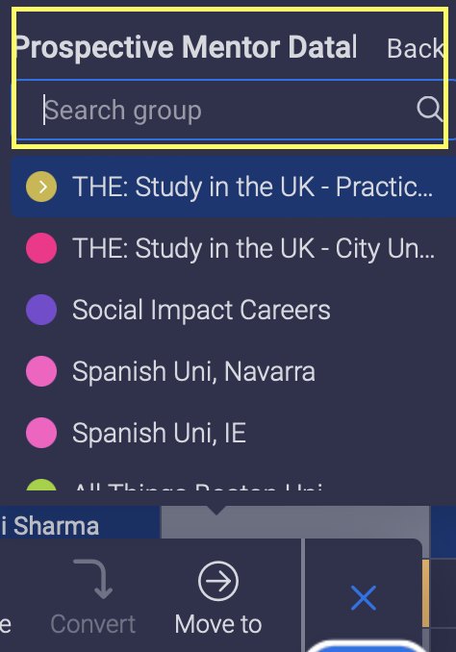

1. The final step is to apply the mapping. Follow the yellow highlights and enter the same thing:

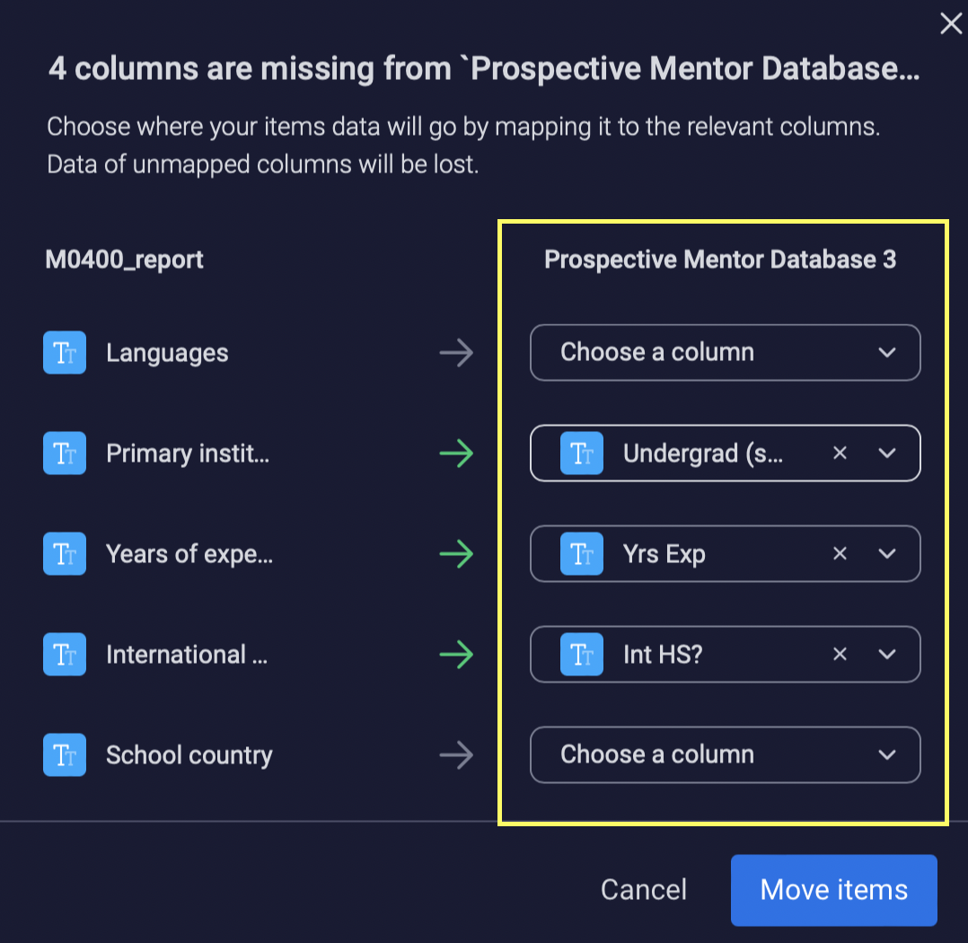

Scroll down:

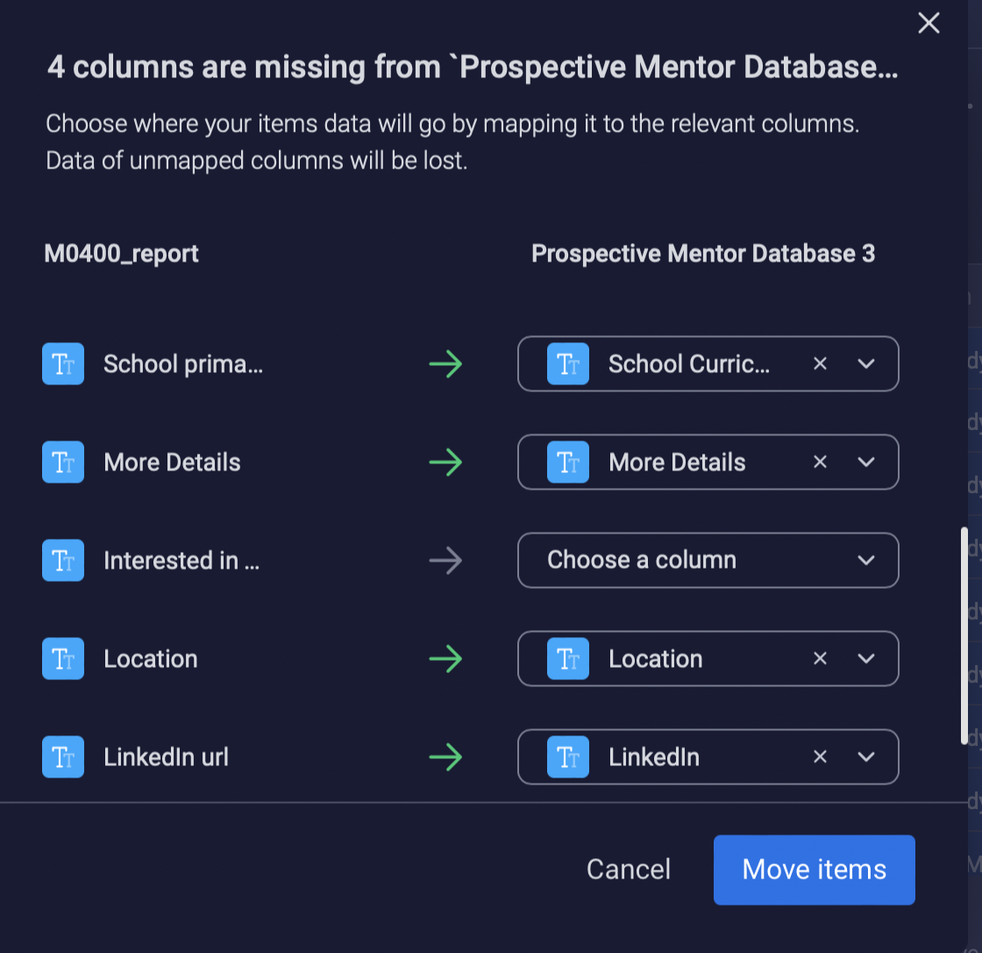

Scroll down:

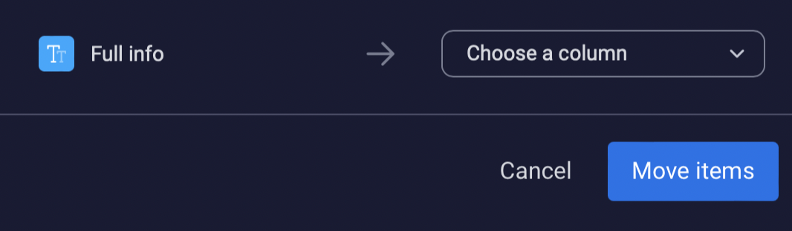

1. Once the mapping is complete, click ‘Move Items’ on the bottom right. And that’s the upload done!